# 

# 

# 

# Team Tetrahedron

Milestone #7 - Experiments



Team members:

Lauro Fialho Müller

Chandan Radhakrishna

Raghava Vinaykanth Mushunuri

Kavya Vajja

Arnab Das

Anjan Chatterjee

30.06.2020

# Table of contents

Table of contents 1

1. Overview 2

2. Milestone Goals & Variables of Interest 2

3. Statement of Accuracy 3

4. Claims About the System 3

4.1 Low throughput 3

4.2 High time in model 4

4.3 Poor safety 4

5. Description, Justification and Results of Experiments: 5

5.1 Opening one road at a time 5

5.2 Opening non overlapping signals of opposite roads 7

5.3 Allowing cars on blocked tram line 9

5.4 Making a car bridge between AF and EWS 12

5.5 Making a free right lane from LSS 15

6. Recommendations 16

7. Cost overview 18

8. Future work 20

9. Appendix I 21

9.1 Abbreviations 21

# 1. Overview

This document aims at providing a detailed account of the experiments currently performed by Team Tetrahedron, in order to device claims about the systems and formulate the basis of the recommendations. This document also contains relevant data about the output variables of concern along with statements of accuracy.

# 2. Milestone Goals & Variables of Interest:

Goal of this milestone is to find answers for two critical questions.

1. How can we improve the safety of the node?
2. How can we improve the traffic condition of the node?

In order to answer these two questions we need some quantitative measures. So we have identified four output variables. Studying the behavior of these variables would give us the base for our recommendations.

For traffic condition the variables are:

1. Throughput: We are calculating the number of cars going to sink in an hour for each of the roads, as well as cumulative throughput of the system. We want this to go up to augment traffic conditions of the node.
2. Time in Model: This variable measures the average time taken by a car to go from source to sink in seconds. Our aim is to minimize this count.
3. Queue Length: This tells us the queue length at the signal of each lane of each road. The queue length is measured after the roads are separated in direction wise lanes. High queue length would mean congestion in the system. We also want this count to go down.

For safety we do not have a direct way to measure safety conditions or accidents. The road traffic library used for this simulation program also bars us from simulating any accident in the model. Hence we have come up with an indirect measure. Here the variable of interest is :

1. Stop Count: This variable counts the total number of stops cars are making inside the mail intersection. The idea is, if a car is making a stop inside the intersection, that means its not getting a free way to move forward. The reasons could be, there are cars going straight from right, or there are stopped cars in front or there may be pedestrians crossing the roads. As data provided by the city of Magdeburg suggests that most of the accidents are turning accidents, this car stop can be a potential candidate for accidents. Hence this measure would give us an indirect safety measure. Our goal is to bring down this count as much as possible.

# 3. Statement of Accuracy:

Statement of accuracy is very important before we talk about the results of our experiments or present our claim in terms of variables to demonstrate system behavior.

1. Replications: We have used 100 replications of simulation runs for all our experiments.
2. Randomness: All the runs use unique seed for input distributions
3. Confidence Interval: We are using 99% confidence interval for all out variable measurement.

# 4. Claims About the System

We have observed the behavior of our valid base model and here we make some claims about the existing model.

## 4.1 Low throughput

The base system is producing throughput of 1585 cars on average in an hour. We feel that the count is low, as later on with our experiments we can see that the number can be significantly improved. 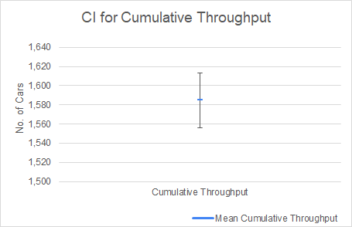

The 99% CI of this throughput measurement is 1556 to 1613 cars.

## 4.2 High time in model

The cars are taking too much time to go from source to sink. Hence after running 100 replications we find that the average time a car spends inside the model is as high as 263 seconds. And the CI varies from 259 to 267 seconds. This is an indication that there is congestion in the system. 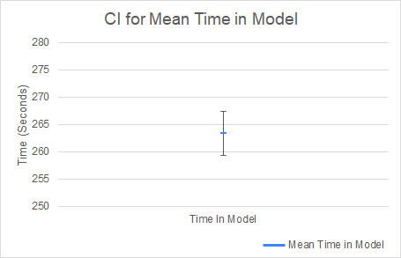

While running the experiments we saw that this can be brought down .

## 4.3 Poor safety

On safety grounds, the existing base model is performing poorly. As the graph shows cars are making 704 stops in an hour inside the main intersection of roads. As this is an indication of a potential candidate for an accident, we can claim that the base model is not very safe for cars turning from one road to another inside the intersections. 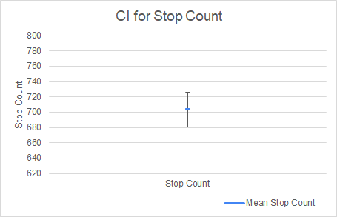

# 5. Description, Justification and Results of Experiments:

In order to find the answers of two original questions we have run several experiments on top of our ground truth model. Here we explain them one by one.

## 5.1 Opening one road at a time

Description: We have played with the traffic signal phases. And we are only opening one road at a time in a particular phase, allowing cars to go all direction from this road, whereas all the traffic signals from all other roads remain red.

Goal: Our aim is to minimize the stop count inside the intersection to improve safety. So that no car crosses each other’s path inside the intersection.

Results:

This experiment produces significant improvement in terms of safety. But it has an adverse impact on throughput and time in the model. Here we present the result in terms of CIs, side by side with its value from base model.

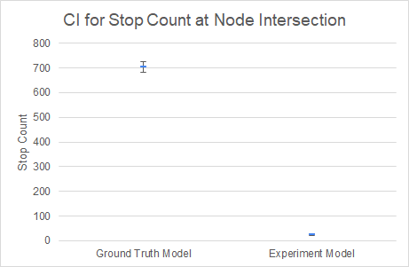 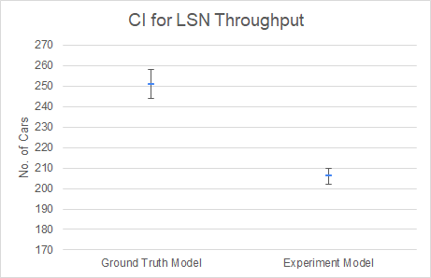

As we can see the mean for stop count has come down from 704 to mere 26 with a CI from 23 to 29. But it also reduces the throughput Leipziger Strasse North(LSN) to a mean of 206 cars, and the 99% CI for this is 202 to 210 cars.

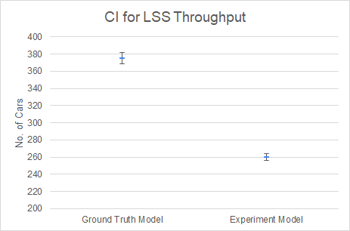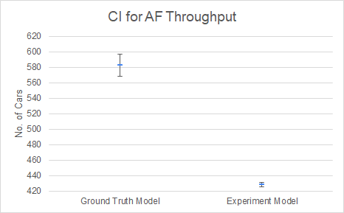

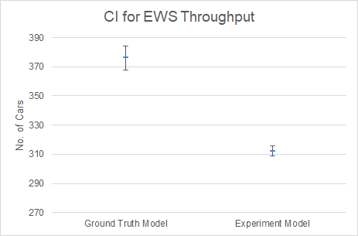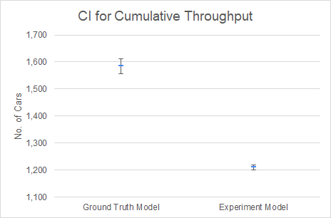

Throughput for other roads also has come down.

In the experiment model Mean for Leipziger Strasse South(LSS) has come down from 375 to 260 compared to the base model. Post experiment, the CI is in between 256 to 264.

For Am Fuchsberg(AF) the mean in experiment model is 428 cars with a CI of 425 to 431 and for Erich-Weinert Strasse(EWS) the mean has come down to 312 cars with a CI between 309-316 cars.

This significantly reduces the overall throughput, and it has come down to only 1210 cars with a CI from 1200 cars to 1218 cars.

The result is quite obvious, as there is overlapping cars in the intersection the car stops less often and moves freely inside the intersection, that why there is so significant improvement but on other hand only one road is green at some point of time cars at other road have to wait to turn their signal green, so the overall throughput goes down when measured for a hour.

## 5.2 Opening non overlapping signals of opposite roads

This experiment is built on top of the last experiment.

Description: In this experiment we are opening non overlapping signals for opposite roads. In single phase cars going straight and right from opposite roads are open and in next phase cars going left are open. Then these two phases repeat for the other two roads.

Goal: Again we are trying to achieve safer road intersection by reducing car stop count inside the intersection.

| Phase 1 | Cars going straight and turning right from LSS and LSN |
| --- | --- |
| Phase 2 | Cars going left from LSS and LSN |
| Phase 3 | Cars going straight and turning right from AF and EWS |
| Phase 4 | Cars going left from AF and EWS |

Results:

This experiment produces significant improvement in terms of safety and also the throughput is also similar in comparison with the base model.

With this experiment the number of stops inside the main intersection diminishes. The mean count goes down to 28 compared to 704 from the base model. The CI for the car stop count is 24-31 with the experiment.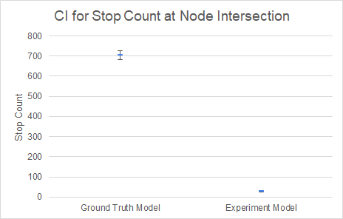

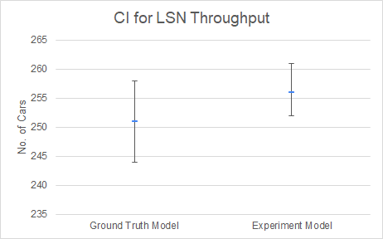 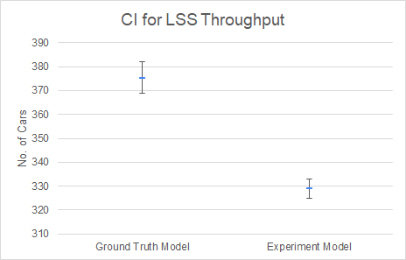

The CIs for LSN throughput in both the models are overlapping. The Mean for LSN throughput is 256 whereas its 251 in the ground truth model. The throughput drops a little bit for LSS from 375 to 329 cars.

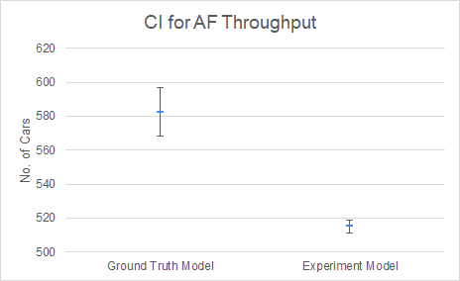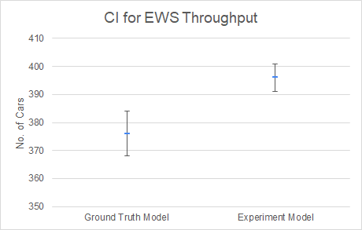

Again for AF the throughput goes slightly down from a mean of 582 cars to 515 cars. But for EWS the throughput goes slightly up from a mean of 376 cars to 396 cars. The charts show the CI ranges.

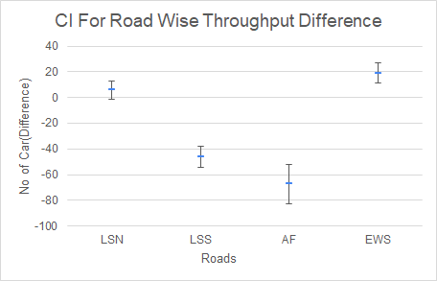

As the CIs are very close we tried find the statistical significance by plotting the CI for road wise throughput differences of the two systems. We see that 0 is in between the CI for LSN. CIs for LSS and AF are marginally below 0 whereas, its above 0 for EWS. So in terms of throughput we can’t conclude which system is better. But it definitely provides safety benefits.

As justification about the results of this experiment, as the non overlapping directions are only open there is no need for the car to stop inside the intersection. Hence safety is improved for the turning cars.

## 5.3 Allowing cars on blocked tram line

Description: There backward left lane on Leipziger Strasse North is blocked for trams only. In this experiment we allowed the cars to avail that road.

Goal: Goal of this experiment is to boost throughput of the system.

Results:

We could find the average benefit of throughput via this experiment whereas the safety conditions are similar with the base model.

As you can see CIs for stop count inside the intersection are overlapping when we compare the ground truth model with this experiment’s model. So we cant really say which system is better or worse in terms of safety.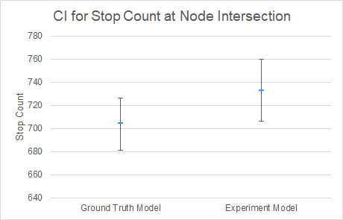

The mean value of car stop count is 733 for the experiment whereas the CI varies from 706 to 760.

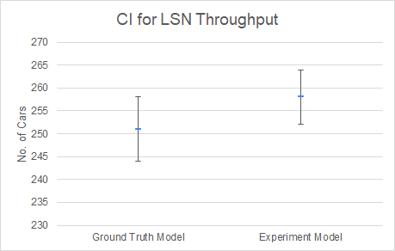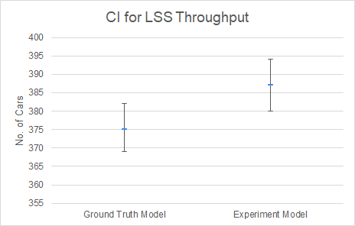

The CIs for throughput are overlapping for both LSN and LSS , though the mean(258 for LSN and 387 for LSS) is slightly on upped side in the experiment model. But without looking at the statistical significance CI we can’t really say which one is better.

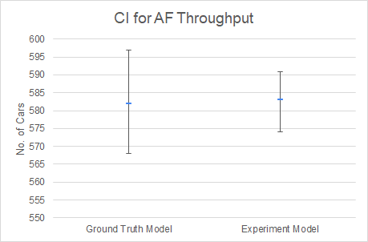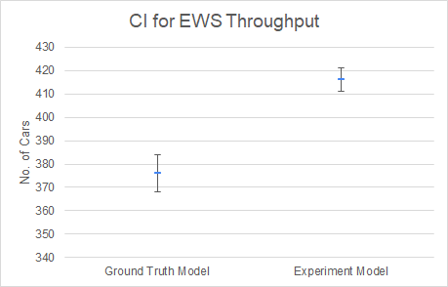

Again the number for Am Fuchsberg is very near to each other. Whereas the throughput for Erich weinert strasse the throughput increases in the experiment model. The mean for EWS throughput is 416 and the CI ranges from 411 to 421.

The mean for cumulative throughput for the experiment is 1645 and the CI is 1630 to 1660 cars in an hour.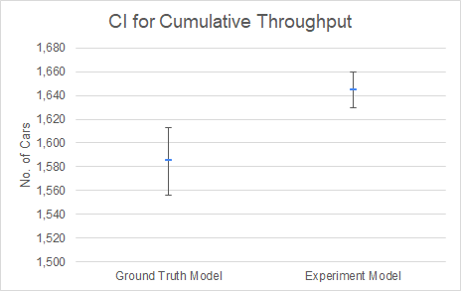

In comparison with the ground truth model it’s slightly better.

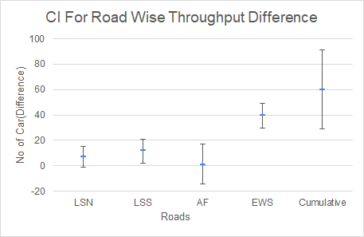

To be absolutely sure, we have plotted the CIs for the throughput difference in experiment model and base model. As we can see for LSN and AF the throughput is similar as they have 0 inside CI. But the CIs for LSS, EWS and cumulative count, are above 0. So we can conclude this experiment adds to traffic improvement.

## 5.4 Making a car bridge between AF and EWS

Cars going straight from Am Fuchsberg to Erich-Weinert Strasse and vice versa are the major component for the throughput.

Details: We made a car bridge between AF and EWS for the cars going straight so that those cars can avoid the main intersection.

Goal: The goal of this experiment is to boost throughput, as cars going straight need not to wait at the signal.

Results:

This experiment produces very significant improvement for the traffic condition of the node. Safety conditions for the node are also improved.

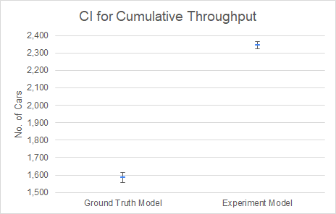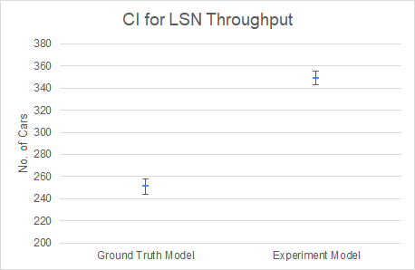

For the experiment model the mean value for cumulative throughput is 2343 cars and the CI varies from 2322 to 2363 cars. The mean throughput for LSN increases from 251 cars in an hour to 349 cars.

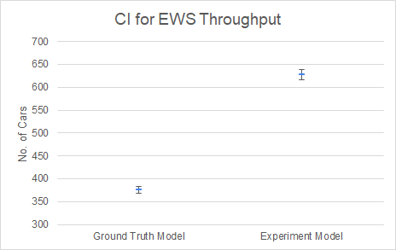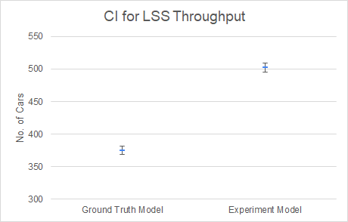

The mean throughput for EWS increases from 376 cars to 627 cars whereas for LSS the mean throughput value increases from 375 cars to 502 cars.

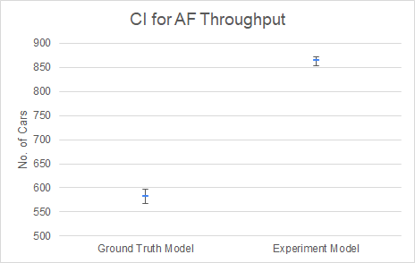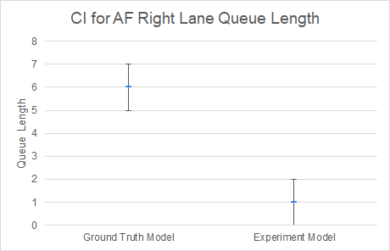

The AF throughput mean value rises to 864 cars from a mean of 582 cars in base model. Whereas the CI varies from 854 to 872. This experiment also makes the queue length lower for the AF right lane, as the cars going straight now avail the bridge , the average queue length at the signal goes from 6 cars at each time step to 1 car, and the CI varies from 0 to 2.

This experiment also helps to make the node a bit safer by reducing the number of car stops inside the main intersection. The mean for the stop count in the experiment model is now 494 and the CI is in range 478-511.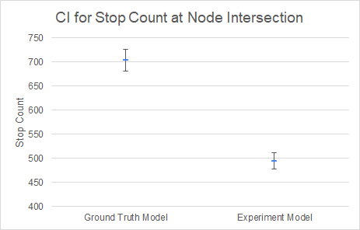

As the result shows this experiment adds very significant improvement towards the node’s traffic condition. As the cars going straight from both AF and EWS are not having any congestion and wait time, automatically the throughput increases.

## 5.5 Making a free right lane from LSS

Details: In this experiment we have made a free right lane from Leipziger strasse south towards Erich-Weinert Strasse, for the cars turning right.

Goal: The aim of this experiment was to increase throughput as the cars turning right need not to wait for the signal.

Results:

This experiment didn’t produce the result we expected; we didn’t get throughput improvement nor safety improvement. As the result is very similar to the results of the base model, we tried to weigh the models drawing the CI for the difference of two models’ results.

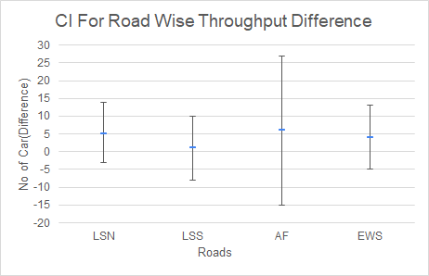

As per the above chart all the CIs are having 0 inside, so statistically cant say which system is better in terms of throughput.

# 6. Recommendations:

For this along with traffic and safety benefits we tried to imagine the cost aspect as well. We recommend changing the traffic signal phases to open only opposite and non overlapping directions like our experiment. This is a low cost change but adds huge safety benefit.

We then recommend allowing cars on the blocked tram lane on LSN backward direction. The cost of the change would be medium but it adds average improvement for traffic conditions.

Finally we recommend building a bridge or underpass for cars going straight in between AM and EWS. The cost of this change would be high but this adds high improvement for the traffic throughput.

| Recommendations | Cost | Improvements |
| --- | --- | --- |
| Open opposite not overlapping signals for cars | Low | Highly significant safety improvement |
| All cars to go on blocked tram lane on LSN | Medium | Average traffic condition improvement |
| Make a bridge or underpass for cars going straight in between AF and EWS | Very High | Highly significant traffic improvement along with average safety improvement |

So to prove our recommendations we have also put all these changes together in a model. And measured the output variables again.

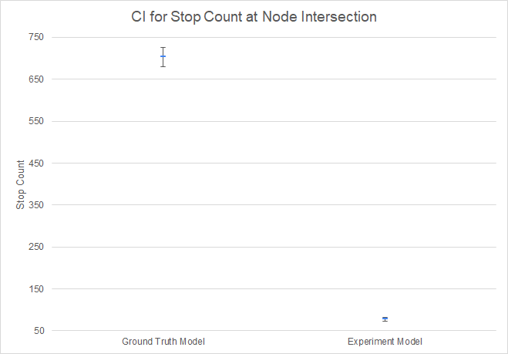

As the CI shows the models with our recommendations shows definite improvement in terms of safety. The count for car stops inside the intersection has come down to 78 from 704 in the earlier base model.

And for the recommendation model the CI varies from 73 to 82.

So we can say our recommendations have proven safety benefit, its also necessary to look at the throughput results.

As we can see the overall throughput increase by at least 20%.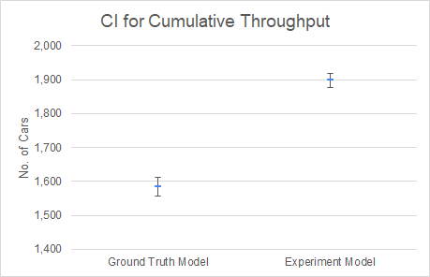

As the mean value goes up from 1585 cars in an hour to 1899 cars.

Whereas the CI varies from 1878 to 1919 cars.

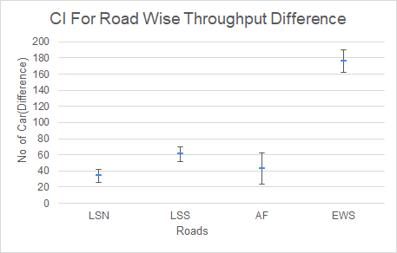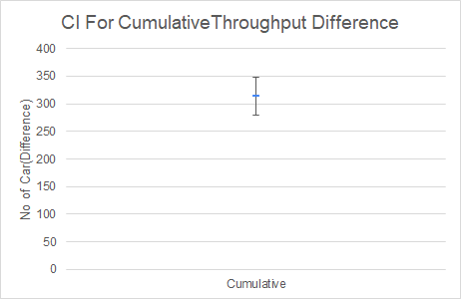

So when we again plot the CI for the Difference for all the roads and for the overall throughput the CI for the difference is clearly above 0. Hence we can also conclude that our recommendations are valid and certainly add traffic improvements.

# 7. Cost overview

The chart in the next page presents a two-dimensional breakdown of costs, aggregated by both milestones and individual members. As planned during Milestone 2, we have already started working on the final documentation to keep it updated with the developments of each individual milestone.

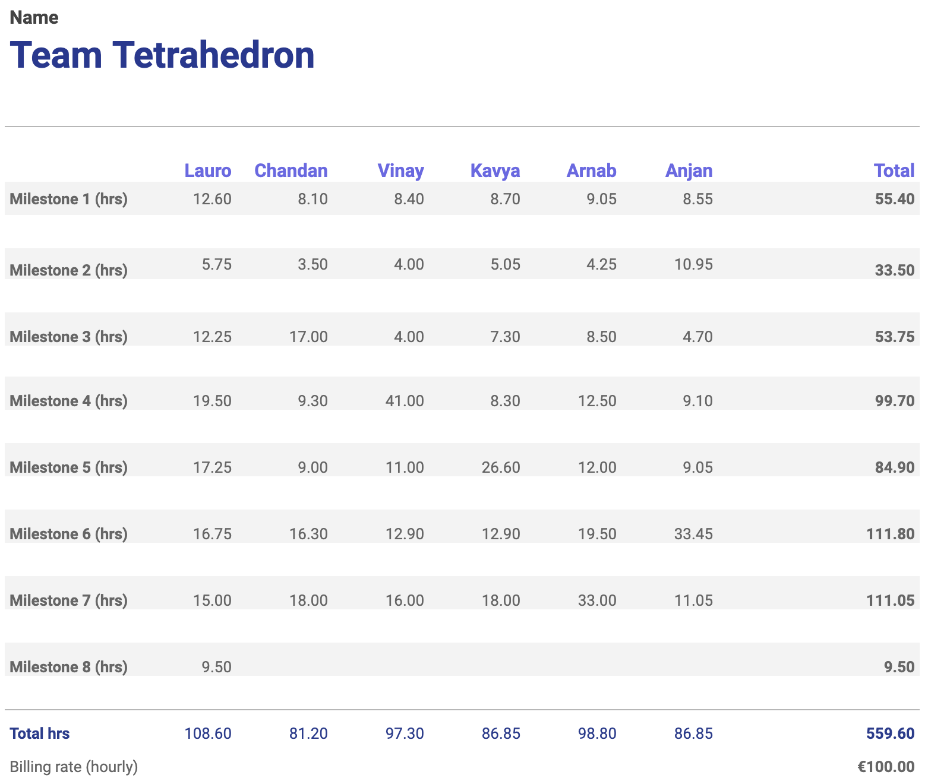

Additionally, the chart below shows the cumulative cost of the project so far. The orange bars represent the planned milestone costs, and the blue line the planned cumulative cost. The green bars represent the actual milestone costs, and the red line the actual cumulative cost.

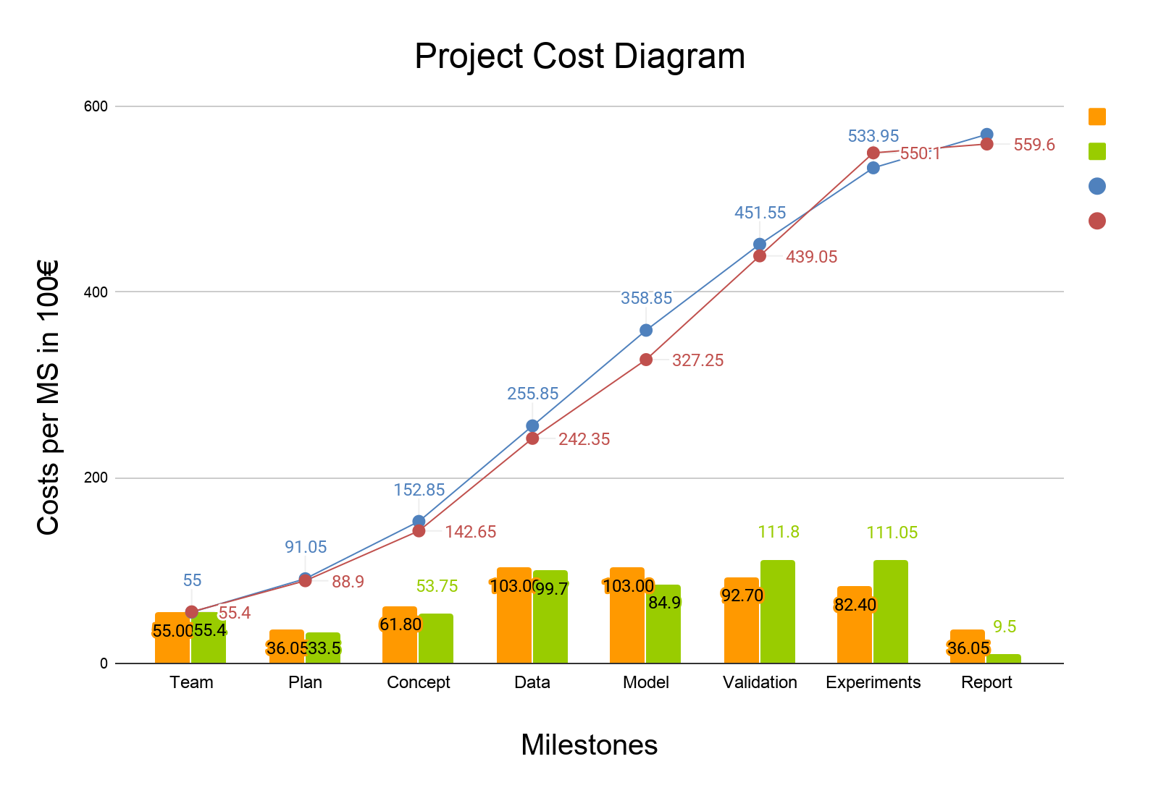

# 

# 8. Future work

As we have done all sorts of experiments with our model in order to find answers for the original question and we have provided our recommendations with valid proof and statistical data. Our main goal forward would be to solely work on consolidating work from all milestones and make a very very detailed report about our project. And also to include proper and understandable justification for all of our assumptions and decisions, so that our customer can gain tangible benefit from it.

# 9. Appendix I:

## 9.1 Abbreviations:

Leipziger Strasse North : LSN

Leipziger Strasse South : LSS

Erich-Weinert Strasse : EWS

Am Fuchsberg : AF

**Anylogic cloud Link to the simulation model with all our recommendations**

<https://cloud.anylogic.com/model/e74fc281-db25-4c33-b8b5-c9a9e6b0895d?mode=SETTINGS>